**Deep learning vs. Machine learning vs. Artificial Intelligence**

Deep Learning, Machine Learning, and Artificial Intelligence are the most used terms on the internet for IT folks. However, all these three technologies are connected with each other. ***Artificial Intelligence (AI) can be understood as an umbrella that consists of both Machine learning and deep learning.*** Or We can say deep learning and machine learning both are subsets of artificial intelligence.

As these technologies look similar, most of the persons have misconceptions about 'Deep Learning, Machine learning, and Artificial Intelligence' that all three are similar to each other. But in reality, although all these technologies are used to build intelligent machines or applications that behave like a human, still, they differ by their functionalities and scope.

It means these three terms are often used interchangeably, but they do not quite refer to the same things. Let's understand the fundamental difference between deep learning, machine learning, and Artificial Intelligence with the below image.

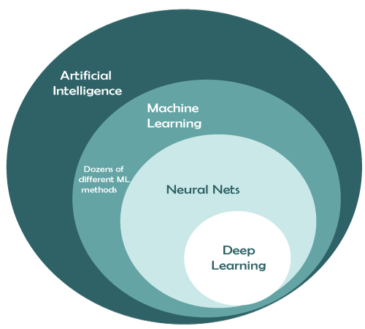

With the above image, you can understand Artificial Intelligence is a branch of computer science that helps us to create smart, intelligent machines. Further, ML is a subfield of AI that helps to teach machines and build AI-driven applications. On the other hand, Deep learning is the sub-branch of ML that helps to train ML models with a huge amount of input and complex algorithms and mainly works with neural networks.

In this article, "Deep Learning vs. Machine Learning vs. Artificial Intelligence", we will help you to gain a clear understanding of concepts related to these technologies and how they differ from each other. So, let's start this topic with each technology individually.

**What is Artificial Intelligence (AI)?**

***Artificial Intelligence is defined as a field of science and engineering that deals with making intelligent machines or computers to perform human-like activities.***

Mr. **John McCarthy** is known as the godfather of this amazing invention. There are some popular definitions of AI, which are as follows:

* "AI is defined as the capability of machines to imitate intelligent human behavior."
* "A computer system able to perform tasks that normally require human intelligence, such as visual perception, speech recognition, decision-making, and translation between languages."

**Types of Artificial Intelligence**

AI can be categorized mainly into 4 types as follows:

* Reactive machine
* Limited memory
* Theory of Mind
* Self-awareness

**Application of Artificial Intelligent**

* Language Translations
* AI in healthcare
* Speech recognition, text recognition, and image recognition
* AI in astronomy
* AI in gaming
* AI in finance
* AI in data security
* AI in social media
* AI in travel and transport
* AI in Automotive Industry
* AI in robots
* AI in Entertainment, agriculture, E-commerce, education, etc.

We have taken a basic knowledge of Artificial Intelligence. Now, let's discuss the basic understanding of Machine Learning.

**What is Machine Learning?**

Machine Learning is defined as the branch of Artificial Intelligence and computer science that focuses on learning and improving the performance of computers/machines through past experience by using algorithms.

AI is used to make intelligent machines/robots, whereas machine learning helps those machines to train for predicting the outcome without human intervention.

**How does Machine Learning work?**

Machine Learning uses algorithms and techniques that enable the machines to learn from past experience/trends and predict the output based on that data.

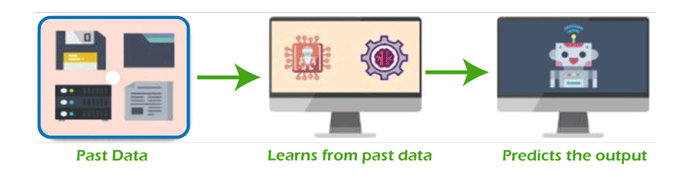

However, firstly, machine learning access a huge amount of data using data pre-processing. This data can be either structured, semi-structured, or unstructured. Further, this data is fed through some techniques and algorithms to machines, and then based on previous trends; it predicts the outputs automatically.

After understanding the working of machine learning models, it's time to move on to types of machine learning.

**Types of Machine Learning**

Based on the methods and techniques to teach machines, Machine Learning is categorized into mainly four types, which are as follows:

**Supervised Machine Learning**

This type of ML method uses labeled datasets to train machines and, based on these datasets, machines predict the output. It needs supervision to train models and predict outputs. **Image segmentation, medical diagnosis, fraud detection, spam detection, speech recognition,** etc., are some important applications of supervised machine learning.  
Supervised machine learning can be further categorized into 2 types of problems as follows:

* **Classification**
* **Regression**

**Advantages of Supervised machine learning**

* Supervised machine learning helps to predict output based on prior experience
* It helps to provide an exact idea about classes of objects.
* **Disadvantages of Supervised machine learning**
* This method is not significant in solving complex problems.
* This method does not guarantee to give exact output as it contains both structured and unstructured data.
* It needs more computational time to teach ML models.

**Unsupervised Machine Learning**

Unsupervised machine learning is just the opposite of supervised learning. Unlike supervised machine learning, it does not need supervision, which means it does not require labeled datasets to train machines. Hence, in unsupervised machine learning, the output is predicted without any supervision. The main aim of the unsupervised learning algorithm is to group or categorize the unsorted dataset according to the similarities, patterns, and differences. **Network analysis, recommendation system, anomaly detection, singular value decompositions,** etc., are some important applications of unsupervised machine learning.  
Unsupervised machine learning is further categorized into two types:

* **Clustering**
* **Association**

**Advantages of unsupervised machine learning**

* It can be used to solve complex ML problems as it works with unlabelled data sets.
* It is used to solve multiple tasks in comparison to supervised learning.

**Disadvantages of unsupervised machine learning**

* Using unlabeled data sets may predict inaccurate outputs.
* It is a relatively complex algorithm as it deals with unlabelled datasets and also does not map with output.

**Semi-supervised Machine learning**  
Semi-supervised learning is the combination of both supervised and unsupervised machine learning. Although it uses both labeled and unlabelled datasets to train models and predict the output, mostly, it contains the unlabelled datasets.  
**Advantages of Semi-supervised machine learning**

* It is simple and easy to understand the algorithm.
* It is more efficient.
* It is used to solve the drawbacks of Supervised and Unsupervised Learning algorithms.

**Disadvantages of Semi-supervised machine learning**

* It does not include applicable network-level data
* It gives less accurate results
* Iterations results may not be stable.

**Reinforcement Learning**  
Reinforcement learning is defined as the feedback-based method to learn from past experience and improve the performance of models. In this method, an AI agent automatically explores its surrounding by hitting and trial actions.  
Further, in reinforcement learning algorithms, machines learn from experience or past data and do not use labeled data. It can be applied in various real-world cases such as video games, resource management, robotics, text mining, operations & research, etc.  
Reinforcement learning is further categorized into two types:

* **Positive reinforcement learning**
* **Negative reinforcement learning**

**Advantages of reinforcement learning**

* It is used to resolve complex real-time scenarios where all other techniques are not useful.
* It provides the most accurate results because it learns similarly to a human.
* It is significant for achieving long-term results.

**Disadvantages of Reinforcement Learning**

* It is not significant for simple scenarios.
* It needs a vast amount of data as well as computations.

**Steps involved in machine learning**

There are 7 simple steps involved in machine learning as follows:

* Data gathering
* Data pre-processing
* Choose model
* Train model
* Test model
* Tune model
* Prediction

We have discussed machine learning and artificial intelligence basics, and it's time to move towards the basics of deep learning.

**What is Deep Learning?**

*"Deep learning is defined as the subset of machine learning and artificial intelligence that is based on artificial neural networks".* In deep learning, **the deep word refers to the number of layers in a neural network.**

Deep Learning is a set of algorithms inspired by the structure and function of the human brain. It uses a huge amount of structured as well as unstructured data to teach computers and predicts accurate results. The main difference between machine learning and deep learning technologies is of presentation of data. Machine learning uses structured/unstructured data for learning, while deep learning uses neural networks for learning models.

In machine learning, if a model predicts inaccurate results, then we need to fix it manually. Further, in deep learning techniques, these problems get fixed automatically, and we do not need to do anything explicitly. A self-driving vehicle is one of the best examples to understand deep learning.

Deep learning can be useful to solve many complex problems with more accurate predictions such as **image recognition, voice recognition, product recommendations systems, natural language processing** (NLP), etc.

**The basic structure of deep learning**

Deep learning includes various neural networks that possess different layers, such as input layers, hidden layers, and output layers. The input layer accepts input data; hidden layers are used to find any hidden pattern and feature from the data, and output layers show the expected results.

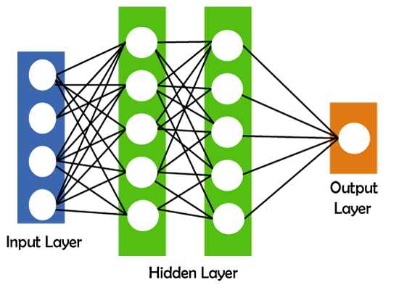

**How does deep learning work?**

There are a few simple steps that deep learning follows.

1. Calculate the weighted sum
2. Use this weighted sum in step1 as input for the activation function.
3. The activation function adds bias and decides whether the neuron should be triggered or not.
4. Predict output at the output layer.
5. Compare predicted output and actual output and accordingly use the backpropagation method for improving the performance of the model. In this step, the cost function plays a vital role in reducing the error rate.

**Types of deep neural networks**

There are some different types of deep learning networks available. These are as follows:

* Feedforward neural network
* Radial basis function neural networks
* Multi-layer perceptron
* Convolution neural network (CNN)
* Recurrent neural network
* Modular neural network
* Sequence to sequence models

**Applications of deep learning**

Deep learning can be applied in various industries such as:

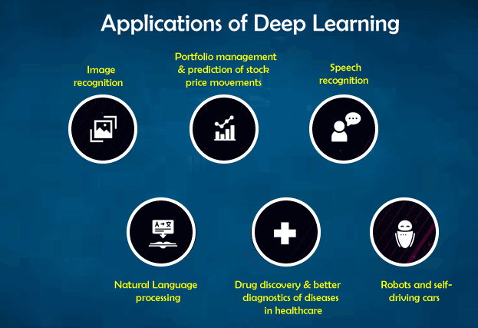

* Self-driving vehicles
* Fraud detection
* Natural language processing
* Virtual personal assistance
* Text, speech, and image recognition
* Healthcare, infrastructure, banking & finance, marketing
* Entertainment
* Education
* Automatic game playing
* Auto handwriting generation
* Automatic language translation
* Pixel restoration and photo description & tagging
* Demographic and election predictions, etc.

**Conclusion**

Artificial intelligence is one of the most popular 5th generation technologies that is changing the world using its subdomains, machine learning, and deep learning. *AI helps us to create an intelligent system and provide cognitive abilities to the machine. Further, machine learning enables machines to learn based on experience without human intervention and makes them capable of learning and predicting results with given data. At the same time, deep learning is the breakthrough in the field of AI that uses various layers of artificial neural networks to achieve impressive outputs for various problems such as image recognition and text recognition.* Hence, after reading this topic, you can say there is no confusion to differentiate these terms that most people face. This topic must have given you enough confidence to understand the basic difference between artificial intelligence (AI), machine learning (ML), and deep learning (DL).